**Query 1**

**Send Feedback**

**Problem Statement:**  
Write an SQL query to add a new column *“transaction_type”*, for the **transactions**table.

Note: Datatype for transaction_type is VARCHAR(225).

**Information about the tables:**  
Given below is a database of a newly established e-commerce website. The database contains multiple tables i.e. products, orders, and transactions. The information about required tables is given below  
  
Table **transactions:**  
Attributes list: 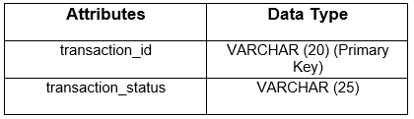  
Data list: 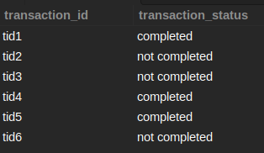

Note: Describe the complete table afterwards.

DESC table_name;

ALTER TABLE transactions add column transaction_type VARCHAR(225);

DESC transactions;

**Query 2**

**Send Feedback**

**Problem Statement:**  
Create the customers table for this database.  
The attributes and their respective datatypes are as follows: 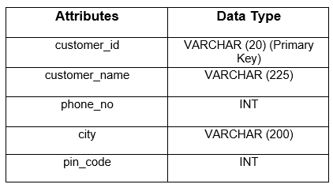

**Information about the tables:**  
Given below is a database of a newly established e-commerce website. The database contains multiple tables i.e. products, orders, and transactions. The information about required tables is given below  
  
Table **transactions:**  
Attributes list: 

Note: Describe the complete table afterwards.

DESC table_name;

+---------------+--------------+------+-----+---------+-------+

| Field | Type | Null | Key | Default | Extra |

+---------------+--------------+------+-----+---------+-------+

| customer_id | varchar(20) | NO | PRI | NULL | |

| customer_name | varchar(225) | YES | | NULL | |

| phone_no | int | YES | | NULL | |

| city | varchar(200) | YES | | NULL | |

| pin_code | int | YES | | NULL | |

+---------------+--------------+------+-----+---------+-------+

CREATE TABLE customers(

customer_id VARCHAR(20),

customer_name VARCHAR(225),

phone_no INT,

city VARCHAR(200),

pin_code INT,

PRIMARY KEY(customer_id)

);

DESC customers;

**Query 3**

**Send Feedback**

**Problem Statement:**  
Write an SQL query to print all the details of the products whose seller’s name ends with ‘n’ and contains only seven alphabets.  
  
**Information about the tables:**  
Given below is a database of a newly established e-commerce website. The database contains multiple tables i.e. products, orders, and transactions. The information about required tables is given below.  
  
Table **product:**  
Attributes list:   
Data list: 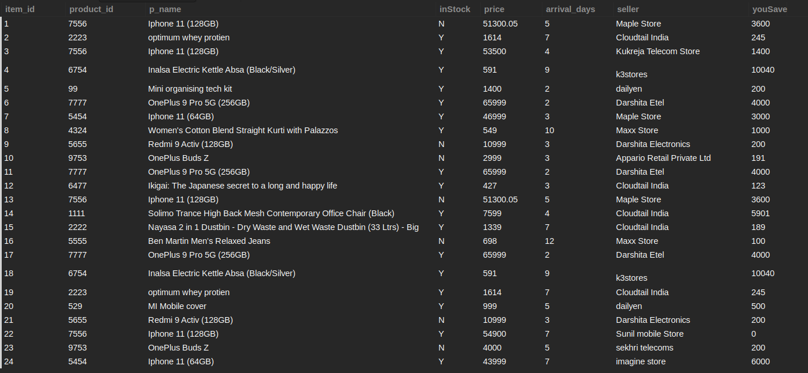  
  
**Output Table Structure :**

+---------+------------+--------------------------+---------+-------+--------------+---------+---------+

| item_id | product_id | p_name | inStock | price | arrival_days | seller | youSave |

+---------+------------+--------------------------+---------+-------+--------------+---------+---------+

| 5 | 99 | Mini organising tech kit | Y | 1400 | 2 | dailyen | 200 |

| 20 | 529 | MI Mobile cover | Y | 999 | 5 | dailyen | 500 |

+---------+------------+--------------------------+---------+-------+--------------+---------+---------

SELECT * FROM product where seller like '______n';

**Query 4**

**Send Feedback**

**Problem Statement:**  
How many orders are currently being delivered in December 2021?  
  
**Information about the tables:**  
Given below is a database of a newly established e-commerce website. The database contains multiple tables i.e. products, orders, transactions, and customer. The information about required tables is given below  
  
Table **orders:**  
Attributes list: 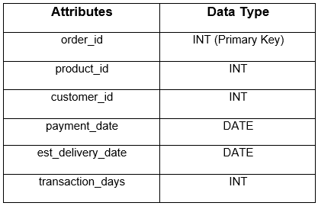  
Data list: 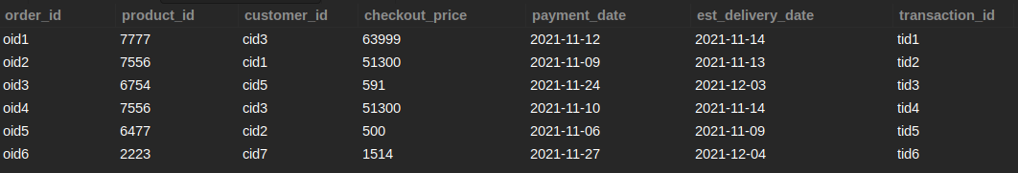  
  
**Output Table Structure**  


Note: Name total number of orders delivered in December, 2021 as **orders_delivered**

+------------------+

| orders_delivered |

+------------------+

| 2 |

+------------------+

SELECT count(*) as orders_delivered from orders

where est_delivery_date between '2021-12-01' and '2021-12-31';

(or)

SELECT count(*) as orders_delivered from orders

where MONTH(est_delivery_date) = 12 and YEAR(est_delivery_date) = 2021;

**Query 5**

**Send Feedback**

**Problem Statement:v**  
Write an SQL query to show only odd rows from the product table.  
  
**Information about the tables:**  
Given below is a database of a newly established e-commerce website. The database contains multiple tables i.e. products, orders, and transactions. The information about required tables is given below  
  
Table **product:**  
Attributes list: 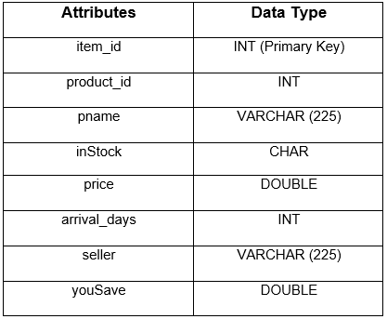  
Data list:   
**Output Table Structure:**  


+---------+------------+-------------------------------------------------------------------------+---------+----------+--------------+-----------------------+---------+

| item_id | product_id | p_name | inStock | price | arrival_days | seller | youSave |

+---------+------------+-------------------------------------------------------------------------+---------+----------+--------------+-----------------------+---------+

| 1 | 7556 | Iphone 11 (128GB) | N | 51300.05 | 5 | Maple Store | 3600 |

| 3 | 7556 | Iphone 11 (128GB) | Y | 53500 | 4 | Kukreja Telecom Store | 1400 |

| 5 | 99 | Mini organising tech kit | Y | 1400 | 2 | dailyen | 200 |

| 7 | 5454 | Iphone 11 (64GB) | Y | 46999 | 3 | Maple Store | 3000 |

| 9 | 5655 | Redmi 9 Activ (128GB) | N | 10999 | 3 | Darshita Electronics | 200 |

| 11 | 7777 | OnePlus 9 Pro 5G (256GB) | Y | 65999 | 2 | Darshita Etel | 4000 |

| 13 | 7556 | Iphone 11 (128GB) | N | 51300.05 | 5 | Maple Store | 3600 |

| 15 | 2222 | Nayasa 2 in 1 Dustbin - Dry Waste and Wet Waste Dustbin (33 Ltrs) - Big | Y | 1339 | 7 | Cloudtail India | 189 |

| 17 | 7777 | OnePlus 9 Pro 5G (256GB) | Y | 65999 | 2 | Darshita Etel | 4000 |

| 19 | 2223 | optimum whey protien | Y | 1614 | 7 | Cloudtail India | 245 |

| 21 | 5655 | Redmi 9 Activ (128GB) | N | 10999 | 3 | Darshita Electronics | 200 |

| 23 | 9753 | OnePlus Buds Z | N | 4000 | 5 | sekhri telecoms | 200 |

+---------+------------+-------------------------------------------------------------------------+---------+----------+--------------+-----------------------+---------+

Select * from product where MOD(item_id,2) != 0;

**Query 6**

**Send Feedback**

**Problem Statement:**  
Make a Clone of the product table(with complete data) and name it to be giftList and print the table schema in ascending order of column name as well.  
  
**Information about the tables:**  
Given below is a database of a newly established e-commerce website. The database contains multiple tables i.e. products, orders, transactions, and customers. The information about required tables is given below  
  
Table **product:**  
Attributes list:   
Data list: 

Note : Command to print table schema:-

SELECT table_name, column_name, data_type

FROM information_schema.columns

WHERE table_name = 'table_name';

+------------+--------------+-----------+

| TABLE_NAME | COLUMN_NAME | DATA_TYPE |

+------------+--------------+-----------+

| giftlist | arrival_days | int |

| giftlist | inStock | char |

| giftlist | item_id | int |

| giftlist | p_name | varchar |

| giftlist | price | double |

| giftlist | product_id | int |

| giftlist | seller | varchar |

| giftlist | youSave | double |

+------------+--------------+-----------+

CREATE TABLE giftList SELECT * FROM product;

SELECT table_name, column_name, data_type

FROM information_schema.columns

WHERE table_name = 'giftList' order by column_name;

**Query - 7**

**Send Feedback**

**Problem Statement:**  
Print out the 6 records from the product table after the 3rd row.  
**Information about the tables:**  
Given below is a database of a newly established e-commerce website. The database contains multiple tables i.e. products, orders, transactions, and customers. The information about required tables is given below  
  
Table **product:**  
Attributes list:   
Data list:   
  
**Output Table Structure:**  


+---------+------------+---------------------------------------------------+---------+-------+--------------+----------------------+---------+

| item_id | product_id | p_name | inStock | price | arrival_days | seller | youSave |

+---------+------------+---------------------------------------------------+---------+-------+--------------+----------------------+---------+

| 4 | 6754 | Inalsa Electric Kettle Absa (Black/Silver) | Y | 591 | 9 |

k3stores | 10040 |

| 5 | 99 | Mini organising tech kit | Y | 1400 | 2 | dailyen | 200 |

| 6 | 7777 | OnePlus 9 Pro 5G (256GB) | Y | 65999 | 2 | Darshita Etel | 4000 |

| 7 | 5454 | Iphone 11 (64GB) | Y | 46999 | 3 | Maple Store | 3000 |

| 8 | 4324 | Women's Cotton Blend Straight Kurti with Palazzos | Y | 549 | 10 | Maxx Store | 1000 |

| 9 | 5655 | Redmi 9 Activ (128GB) | N | 10999 | 3 | Darshita Electronics | 200 |

+---------+------------+---------------------------------------------------+---------+-------+--------------+----------------------+---------+

SELECT * FROM PRODUCT LIMIT 3,6;

**Query - 8**

**Send Feedback**

**Problem Statement:**  
Write a Mysql query to fetch the second most expensive item cost/price.  
  
**Information about the tables:**  
Given below is a database of a newly established e-commerce website. The database contains multiple tables i.e. products, orders, transactions, and customers. The information about different tables is given below  
  
Table **product:**  
Attributes list:   
Data list:   
  
**Output Table Structure :**  


Note: Name the output table as **'maximum_price'**

+---------------+

| maximum_price |

+---------------+

| 54900 |

+---------------+

Select MAX(price) as maximum_price from product

where price not in (SELECT MAX(price) from product);

**Query - 9**

**Send Feedback**

**Problem Statement:**  
Fetch out all the product details of the 7th most expensive product.  
  
**Information about the tables:**  
Given below is a database of a newly established e-commerce website. The database contains multiple tables i.e. products, orders, transactions, and customers. The information about required tables is given below  
  
Table **product:**  
Attributes list:   
Data list:   
  
**Output Table Structure :**  


+---------+------------+-------------------+---------+----------+--------------+-------------+---------+

| item_id | product_id | p_name | inStock | price | arrival_days | seller | youSave |

+---------+------------+-------------------+---------+----------+--------------+-------------+---------+

| 13 | 7556 | Iphone 11 (128GB) | N | 51300.05 | 5 | Maple Store | 3600 |

+---------+------------+-------------------+---------+----------+--------------+-------------+---------+

SELECT * from product order by price desc Limit 6,1;

**Query - 10**

**Send Feedback**

**Problem Statement:**  
Fetch the first 33% records from a product table.  
  
**Information about the tables:**  
Given below is a database of a newly established e-commerce website. The database contains multiple tables i.e. products, orders, transactions, and customers. The information about required tables is given below  
  
Table **product:**  
Attributes list:   
Data list:   
  
**Output Table Structure :**  


SELECT *

FROM PRODUCT WHERE

item_id <= (SELECT COUNT(item_id)*(33/100)+1 from PRODUCT);

+---------+------------+---------------------------------------------------+---------+----------+--------------+-----------------------+---------+

| item_id | product_id | p_name | inStock | price | arrival_days | seller | youSave |

+---------+------------+---------------------------------------------------+---------+----------+--------------+-----------------------+---------+

| 1 | 7556 | Iphone 11 (128GB) | N | 51300.05 | 5 | Maple Store | 3600 |

| 2 | 2223 | optimum whey protien | Y | 1614 | 7 | Cloudtail India | 245 |

| 3 | 7556 | Iphone 11 (128GB) | Y | 53500 | 4 | Kukreja Telecom Store | 1400 |

| 4 | 6754 | Inalsa Electric Kettle Absa (Black/Silver) | Y | 591 | 9 |

k3stores | 10040 |

| 5 | 99 | Mini organising tech kit | Y | 1400 | 2 | dailyen | 200 |

| 6 | 7777 | OnePlus 9 Pro 5G (256GB) | Y | 65999 | 2 | Darshita Etel | 4000 |

| 7 | 5454 | Iphone 11 (64GB) | Y | 46999 | 3 | Maple Store | 3000 |

| 8 | 4324 | Women's Cotton Blend Straight Kurti with Palazzos | Y | 549 | 10 | Maxx Store | 1000 |

+---------+------------+---------------------------------------------------+---------+----------+--------------+-----------------------+---------+

**Query - 11**

**Send Feedback**

**Problem Statement:**  
For each seller, find the number of products he/she is selling.  
  
**Information about the tables:**  
Given below is a database of a newly established e-commerce website. The database contains multiple tables i.e. products, orders, transactions, and customers. The information about required tables is given below  
  
Table **product:**  
Attributes list:   
Data list:   
  
**Output Table Structure :**  


Note: Name the column containing specific number of products as **"nop"**

+----------------------------+-----+

| seller | nop |

+----------------------------+-----+

| Maple Store | 3 |

| Cloudtail India | 5 |

| Kukreja Telecom Store | 1 |

|

k3stores | 2 |

| dailyen | 2 |

| Darshita Etel | 3 |

| Maxx Store | 2 |

| Darshita Electronics | 2 |

| Appario Retail Private Ltd | 1 |

| Sunil mobile Store | 1 |

| sekhri telecoms | 1 |

| imagine store | 1 |

+----------------------------+-----+

SELECT seller,count(*) as nop from PRODUCT group by seller;

**Query - 12**

**Send Feedback**

**Problem Statement:**  
List out the five cheapest prices from the product table. (only need to list the prices)  
  
**Information about the tables:**  
Given below is a database of a newly established e-commerce website. The database contains multiple tables i.e. products, orders, transactions, and customers. The information about required tables is given below  
  
Table **product:**  
Attributes list:   
Data list:   
  
**Output Table Structure :**  


SELECT price from product group by price order by price asc limit 0,5;

+-------+

| price |

+-------+

| 427 |

| 549 |

| 591 |

| 698 |

| 999 |

+-------+

**Query - 13**

**Send Feedback**

**Problem Statement:**  
List out the five most expensive prices from the product table. (only need to list the prices)  
  
**Information about the tables:**  
Given below is a database of a newly established e-commerce website. The database contains multiple tables i.e. products, orders, transactions, and customers. The information about required tables is given below  
  
Table **product:**  
Attributes list:   
Data list:   
  
**Output Table Structure:**  


+----------+

| price |

+----------+

| 65999 |

| 54900 |

| 53500 |

| 51300.05 |

| 46999 |

+----------+

SELECT price from product group by price order by price desc limit 0,5;

**Query - 14**

**Send Feedback**

**Problem Statement:**  
What’s the percentage of the products in stock with savings greater than 4000.  
  
**Information about the tables:**  
Given below is a database of a newly established e-commerce website. The database contains multiple tables i.e. products, orders, transactions, and customers. The information about required tables is given below  
  
Table **product:**  
Attributes list:   
Data list:   
  
**Output Table Structure :**  


+------------+

| percentage |

+------------+

| 23.5294 |

+------------+

SELECT ((count(*)/(SELECT count(*) from product where inStock = 'Y'))*100) as percentage from product where inStock = 'Y' and youSave > 4000;

(or)

SELECT (SELECT COUNT(*) FROM product WHERE inStock = 'Y' AND youSave > 4000) * 100/ (SELECT COUNT(*) FROM product WHERE inStock = 'Y') AS percentage;

**Query - 15**

**Send Feedback**

**Problem Statement:**  
Write a MySQL query to display the last 4 records from the product table.  
  
**Information about the tables:**  
Given below is a database of a newly established e-commerce website. The database contains multiple tables i.e. products, orders, transactions, and customers. The information about required tables is given below  
  
Table **product:**  
Attributes list:   
Data list:   
  
**Output Table Structure :**  


+---------+------------+-----------------------+---------+-------+--------------+----------------------+---------+

| item_id | product_id | p_name | inStock | price | arrival_days | seller | youSave |

+---------+------------+-----------------------+---------+-------+--------------+----------------------+---------+

| 21 | 5655 | Redmi 9 Activ (128GB) | N | 10999 | 3 | Darshita Electronics | 200 |

| 22 | 7556 | Iphone 11 (128GB) | Y | 54900 | 7 | Sunil mobile Store | 0 |

| 23 | 9753 | OnePlus Buds Z | N | 4000 | 5 | sekhri telecoms | 200 |

| 24 | 5454 | Iphone 11 (64GB) | Y | 43999 | 7 | imagine store | 6000 |

+---------+------------+-----------------------+---------+-------+--------------+----------------------+---------+

SELECT * FROM PRODUCT where item_id>(SELECT count(*)-4 from PRODUCT);

(or)

SELECT * FROM (SELECT * FROM PRODUCT ORDER BY item_id desc limit 4) Temp order by item_id asc;

**Query - 16**

**Send Feedback**

**Problem Statement:**  
Find the duplicate product id and seller name along with count of duplicate entries from the tables given below considering there is no primary key (item_id).  
  
**Information about the tables:**  
Given below is a database of a newly established e-commerce website. The database contains multiple tables i.e. products, orders, transactions, and customers. The information about required tables is given below  
  
Table **product:**  
Attributes list:   
Data list:   
  
**Output:**  
The result set should have the product id , seller and its corresponding number of duplicate entries.

+------------+----------------------+----------+

| product_id | seller | count(*) |

+------------+----------------------+----------+

| 7556 | Maple Store | 2 |

| 2223 | Cloudtail India | 2 |

| 6754 |

k3stores | 2 |

| 7777 | Darshita Etel | 3 |

| 5655 | Darshita Electronics | 2 |

+------------+----------------------+----------+

SELECT product_id,seller,count(*) from Product group by product_id,seller having count(*)>1;

**Query - 17**

**Send Feedback**

**Problem Statement:**  
List down the count of all the similar products available across all its sellers.  
  
**Information about the tables:**  
Given below is a database of a newly established e-commerce website. The database contains multiple tables i.e. products, orders, transactions, and customers. The information about required tables is given below  
  
Table **product:**  
Attributes list:   
Data list:   
  
**Output Table Structure**  


#### Note - 1: Name the count of all the similar products as countSame.

#### Note - 2: Arrange the columns in ascending order.

SELECT DISTINCT p.product_id,p.p_name,p.inStock,p.seller,q.countSame

from Product p

INNER JOIN

(SELECT product_id,p_name,inStock,count(*) as countSame

from product

GROUP BY product_id,p_name,inStock

having count(*)>1

AND inStock = 'Y') q

on p.product_id = q.product_id

and p.p_name = q.p_name

and p.inStock = q.inStock

order by p.product_id,p.p_name,p.inStock,p.seller asc;

+------------+--------------------------------------------+---------+-----------------------+-----------+

| product_id | p_name | inStock | seller | countSame |

+------------+--------------------------------------------+---------+-----------------------+-----------+

| 2223 | optimum whey protien | Y | Cloudtail India | 2 |

| 5454 | Iphone 11 (64GB) | Y | imagine store | 2 |

| 5454 | Iphone 11 (64GB) | Y | Maple Store | 2 |

| 6754 | Inalsa Electric Kettle Absa (Black/Silver) | Y |

k3stores | 2 |

| 7556 | Iphone 11 (128GB) | Y | Kukreja Telecom Store | 2 |

| 7556 | Iphone 11 (128GB) | Y | Sunil mobile Store | 2 |

| 7777 | OnePlus 9 Pro 5G (256GB) | Y | Darshita Etel | 3 |

+------------+--------------------------------------------+---------+-----------------------+-----------+

**Query - 18**

**Send Feedback**

**Problem Statement:**  
What is an Average total saving amount on the products sold by Maple store or Kukreja Telecom Store?  
  
**Information about the tables:**  
Given below is a database of a newly established e-commerce website. The database contains multiple tables i.e. products, orders, transactions, and customers. The information about required tables is given below  
  
Table **product:**  
Attributes list:   
Data list:   
  
**Output Table Structure:**  


+------------+

| AVG(TOTAL) |

+------------+

| 8800 |

+------------+

+------------+-------+

| product_id | TOTAL |

+------------+-------+

| 7556 | 8600 |

| 2223 | 490 |

| 6754 | 20080 |

| 99 | 200 |

| 7777 | 12000 |

| 5454 | 9000 |

| 4324 | 1000 |

| 5655 | 400 |

| 9753 | 391 |

| 6477 | 123 |

| 1111 | 5901 |

| 2222 | 189 |

| 5555 | 100 |

| 529 | 500 |

+------------+-------+

SELECT AVG(TOTAL) FROM

(SELECT product_id, SUM(youSave) AS TOTAL FROM product GROUP BY product_id) AS TOTALS WHERE

product_id IN

(SELECT product_id FROM product WHERE seller = 'Maple store' OR seller = 'Kukreja Telecom Store');

**Query - 19**

**Send Feedback**

**Problem Statement:**  
For each product, list down the min price of the product and the average percentage of savings available across all the sellers who sell more than one product.  
  
**Information about the tables:**  
Given below is a database of a newly established e-commerce website. The database contains multiple tables i.e. products, orders, transactions, and customers. The information about required tables is given below  
  
Table **product:**  
Attributes list:   
Data list:   
  
**Output**  
The result set should have product id, product name, minimum price and average percentage as avgP.

+------------+--------------------------------------------+------------+--------------------+

| product_id | p_name | min(price) | avgP |

+------------+--------------------------------------------+------------+--------------------+

| 7556 | Iphone 11 (128GB) | 51300.05 | 25 |

| 2223 | optimum whey protien | 1614 | 50 |

| 6754 | Inalsa Electric Kettle Absa (Black/Silver) | 591 | 50 |

| 7777 | OnePlus 9 Pro 5G (256GB) | 65999 | 33.333333333333336 |

| 5454 | Iphone 11 (64GB) | 43999 | 50 |

| 5655 | Redmi 9 Activ (128GB) | 10999 | 50 |

| 9753 | OnePlus Buds Z | 2999 | 50 |

+------------+--------------------------------------------+------------+--------------------+

SELECT product_id,p_name,min(price),

(avg(youSave)*100)/SUM(youSave) as avgP from product group by product_id,p_name having count(*) > 1

**Query - 20**

**Send Feedback**

**Problem Statement:**  
List all the distinct products which are ordered with their customer id and customer name.  
  
**Information about the tables:**  
Given below is a database of a newly established e-commerce website. The database contains multiple tables i.e. products, orders, transactions, and customers. The information about required tables is given below  
  
Table **product:**  
Attributes list:   
Data list:   
  
Table **orders:**  
Attributes list:   
Data list:   
  
Table **customer:**  
Attributes list:   
Data list: 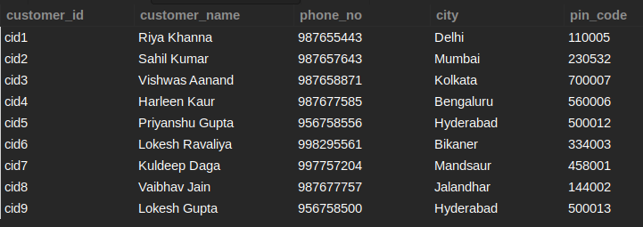  
  
**Output**  
The result set should have the product name, customer id and customer name.

+------------------------------------------------------+-------------+-----------------+

| p_name | customer_id | customer_name |

+------------------------------------------------------+-------------+-----------------+

| Iphone 11 (128GB) | cid3 | Vishwas Aanand |

| Iphone 11 (128GB) | cid1 | Riya Khanna |

| optimum whey protien | cid7 | Kuldeep Daga |

| Inalsa Electric Kettle Absa (Black/Silver) | cid5 | Priyanshu Gupta |

| OnePlus 9 Pro 5G (256GB) | cid3 | Vishwas Aanand |

| Ikigai: The Japanese secret to a long and happy life | cid2 | Sahil Kumar |

+------------------------------------------------------+-------------+-----------------+

SELECT DISTINCT p.p_name,o.customer_id,c.customer_name from orders o inner join customer c

on o.customer_id = c.customer_id

inner join product p

on p.product_id = o.product_id;

**Query - 21**

**Send Feedback**

**Problem Statement:**  
Get the product_id and the number of products ordered for each product_id.  
  
**Information about the tables:**  
Given below is a database of a newly established e-commerce website. The database contains multiple tables i.e. products, orders, transactions, and customers. The information about required tables is given below  
  
Table **product:**  
Attributes list:   
Data list:   
  
Table **orders:**  
Attributes list:   
Data list:   
  
Information about the table **transactions**  
Attributes list:   
Data list:   
  
Table **customer:**  
Attributes list:   
Data list:   
  
**Output:**  
The result set should have product_id , and count of products for each product_id as attributes.

+------------+-------------------+

| product_id | count(product_id) |

+------------+-------------------+

| 7777 | 1 |

| 7556 | 2 |

| 6754 | 1 |

| 6477 | 1 |

| 2223 | 1 |

+------------+-------------------+

SELECT product_id,count(product_id) from orders group by product_id;

**Query - 22**

**Send Feedback**

**Problem Statement:**  
Enlist the transaction_status for all products ordered.  
  
**Information about the tables:**  
Given below is a database of a newly established e-commerce website. The database contains multiple tables i.e. products, orders, transactions, and customers. The information about required tables is given below  
  
Table **product:**  
Attributes list:   
Data list:   
  
Table **order:**  
Attributes list:   
Data list:   
  
Information about the table **transactions:**  
Attributes list:   
Data list:   
  
**Output Table Structure :**  


+----------------+

| transaction_id |

+----------------+

| tid1 |

| tid2 |

| tid3 |

| tid4 |

| tid5 |

| tid6 |

+----------------+

SELECT transactions.transaction_id FROM orders

INNER JOIN transactions ON orders.transaction_ID = transactions.transaction_id;

**Query - 23**

**Send Feedback**

**Problem Statement:**  
List all the product names with their respective payment date and delivery date and sort the output table w.r.t to delivery date.  
  
**Information about the tables:**  
Given below is a database of a newly established e-commerce website. The database contains multiple tables i.e. products, orders, transactions, and customers. The information about required tables is given below  
  
Table **product:**  
Attributes list:   
Data list:   
  
Table **order:**  
Attributes list:   
Data list:   
  
Table **transactions:**  
Attributes list:   
Data list:   
  
**Output**  
The result set should have the product name, payment date and delivery date as columns.

+------------------------------------------------------+--------------+-------------------+

| p_name | payment_date | est_delivery_date |

+------------------------------------------------------+--------------+-------------------+

| Ikigai: The Japanese secret to a long and happy life | 2021-11-06 | 2021-11-09 |

| Iphone 11 (128GB) | 2021-11-09 | 2021-11-13 |

| Iphone 11 (128GB) | 2021-11-10 | 2021-11-14 |

| OnePlus 9 Pro 5G (256GB) | 2021-11-12 | 2021-11-14 |

| Inalsa Electric Kettle Absa (Black/Silver) | 2021-11-24 | 2021-12-03 |

| optimum whey protien | 2021-11-27 | 2021-12-04 |

+------------------------------------------------------+--------------+-------------------+

SELECT DISTINCT product.p_name,orders.payment_date,orders.est_delivery_date

from product

inner join

orders on product.product_id = orders.product_id

order by orders.est_delivery_date;

**Query - 24**

**Send Feedback**

**Problem Statement:**  
List all the not completed transaction_status for all order_id.  
  
**Information about the tables:**  
Given below is a database of a newly established e-commerce website. The database contains multiple tables i.e. products, orders, transactions, and customers. The information about required tables is given below  
  
Table **product:**  
Attributes list:   
Data list:   
  
Table **order:**  
Attributes list:   
Data list:   
  
Table **transactions:**  
Attributes list:   
Data list:   
  
**Output**  
The result set should have the Id, product's Id, customer's Id and the transaction Id's.

+----------+------------+-------------+----------------+

| order_id | product_id | customer_id | transaction_id |

+----------+------------+-------------+----------------+

| oid2 | 7556 | cid1 | tid2 |

| oid3 | 6754 | cid5 | tid3 |

| oid6 | 2223 | cid7 | tid6 |

+----------+------------+-------------+----------------+

SELECT o.order_id,o.product_id,o.customer_id,t.transaction_id

from orders o

inner join

transactions t on o.transaction_id = t.transaction_id

where t.transaction_status = 'not completed';

**Query - 25**

**Send Feedback**

**Problem Statement:**  
List down the product names along with the details like the time the payment for the order was made and delivery date along with the transaction status of that product by the customer and sort it according to their respective payment date.  
  
**Information about the tables:**  
Given below is a database of a newly established e-commerce website. The database contains multiple tables i.e. products, orders, transactions, and customers. The information about required tables is given below  
  
Table **product:**  
Attributes list:   
Data list:   
  
Table **order:**  
Attributes list:   
Data list:   
  
Table **transactions:**  
Attributes list:   
Data list:   
  
Table **customers:**  
Attributes list:   
Data list:   
  
**Output Table Structure**  


+------------------------------------------------------+--------------+-------------------+--------------------+

| p_name | payment_date | est_delivery_date | transaction_status |

+------------------------------------------------------+--------------+-------------------+--------------------+

| Ikigai: The Japanese secret to a long and happy life | 2021-11-06 | 2021-11-09 | completed |

| Iphone 11 (128GB) | 2021-11-09 | 2021-11-13 | not completed |

| Iphone 11 (128GB) | 2021-11-10 | 2021-11-14 | completed |

| OnePlus 9 Pro 5G (256GB) | 2021-11-12 | 2021-11-14 | completed |

| Inalsa Electric Kettle Absa (Black/Silver) | 2021-11-24 | 2021-12-03 | not completed |

| optimum whey protien | 2021-11-27 | 2021-12-04 | not completed |

+------------------------------------------------------+--------------+-------------------+--------------------+

SELECT DISTINCT p.p_name,o.payment_date,o.est_delivery_date,t.transaction_status

from

product p

inner join

orders o

on p.product_id = o.product_id

inner join

transactions t

on t.transaction_id = o.transaction_id

order by o.payment_date;

**Query - 26**

**Send Feedback**

**Problem Statement:**  
Enlist all orders for a customer with “d” in their name.  
  
**Information about the tables:**  
Given below is a database of a newly established e-commerce website. The database contains multiple tables i.e. products, orders, transactions, and customers. The information about required tables is given below  
  
Table **product:**  
Attributes list:   
Data list:   
  
Table **orders:**  
Attributes list:   
Data list:   
  
Table **transactions:**  
Attributes list:   
Data list:   
  
Table **customer**  
Attributes list:   
Data list:   
**Output**  
  
The result set should have the customer's name and order's id.

+----------------+----------+

| customer_name | order_id |

+----------------+----------+

| Vishwas Aanand | oid1 |

| Vishwas Aanand | oid4 |

| Kuldeep Daga | oid6 |

+----------------+----------+

SELECT customer_name,order_id

from customer c

inner join

orders o

on c.customer_id = o.customer_id

where c.customer_name like '%d%';